

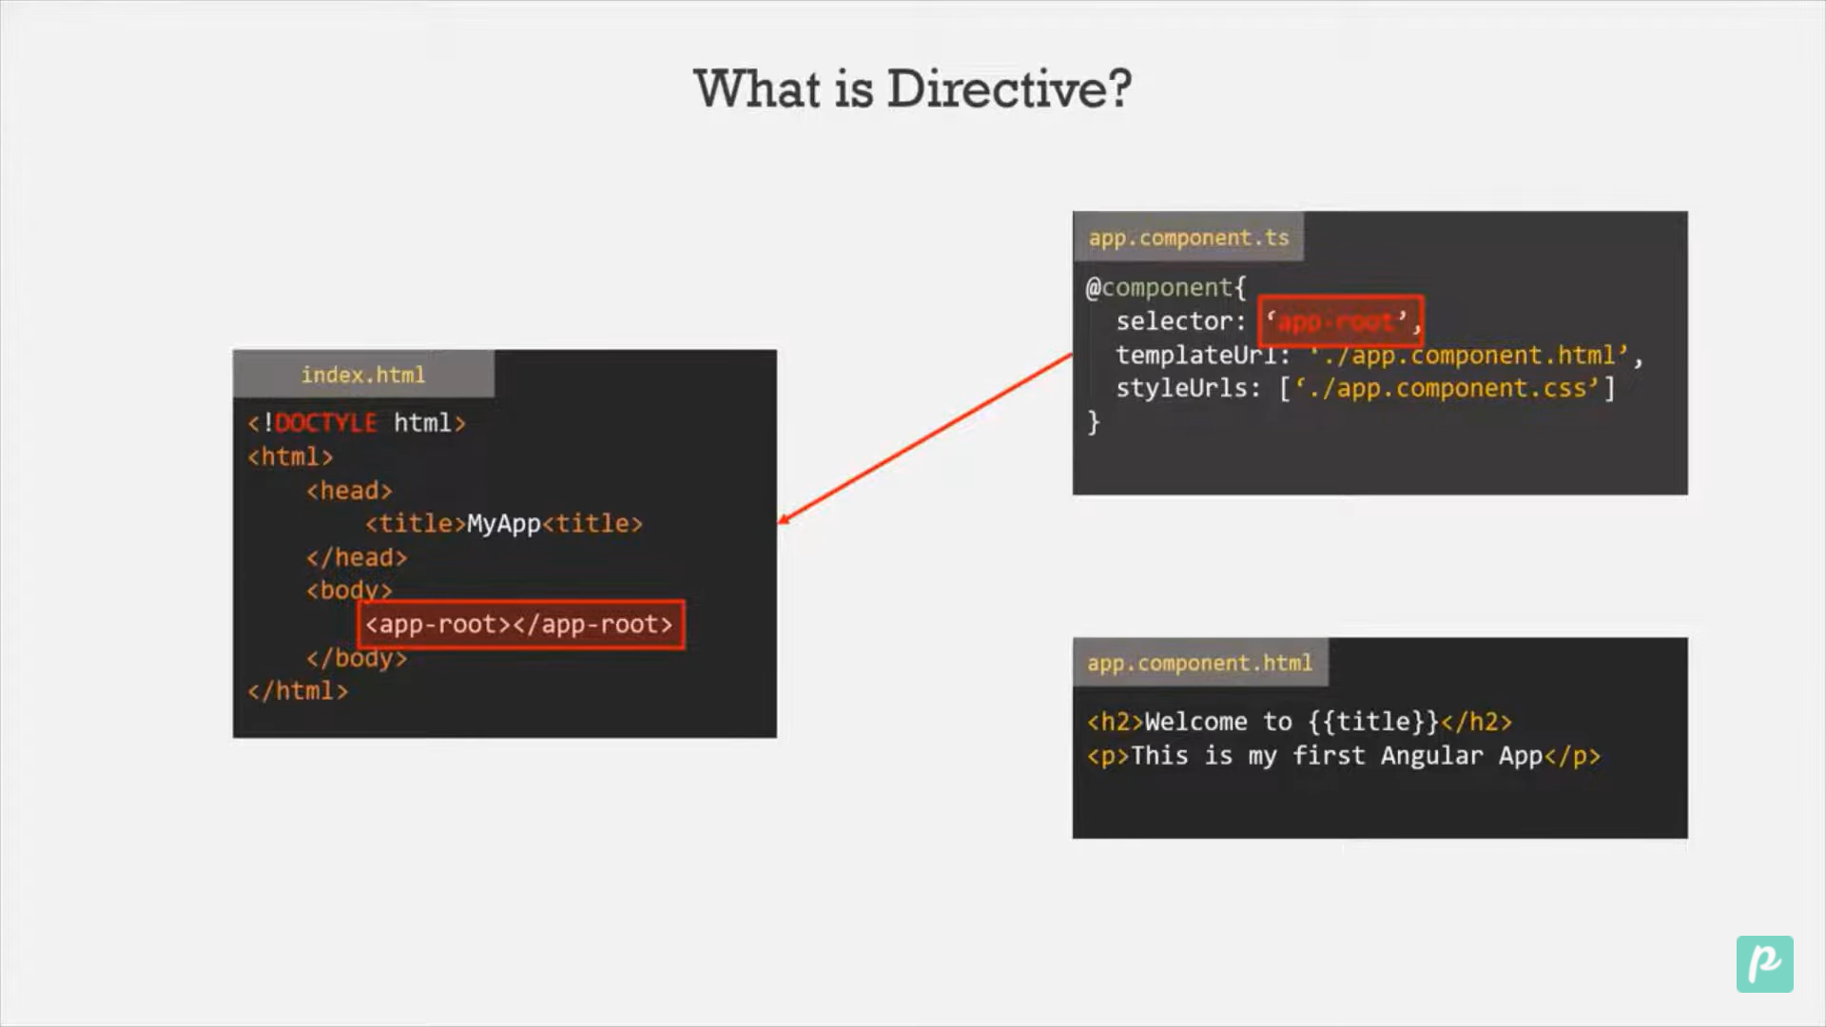

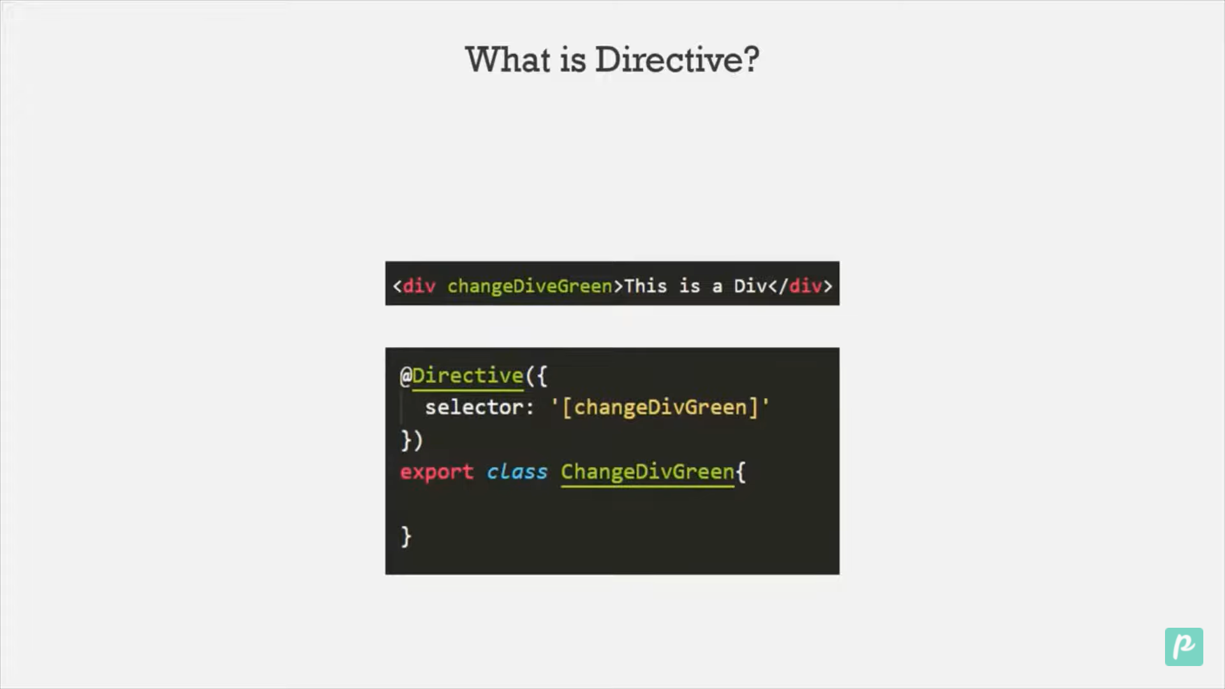

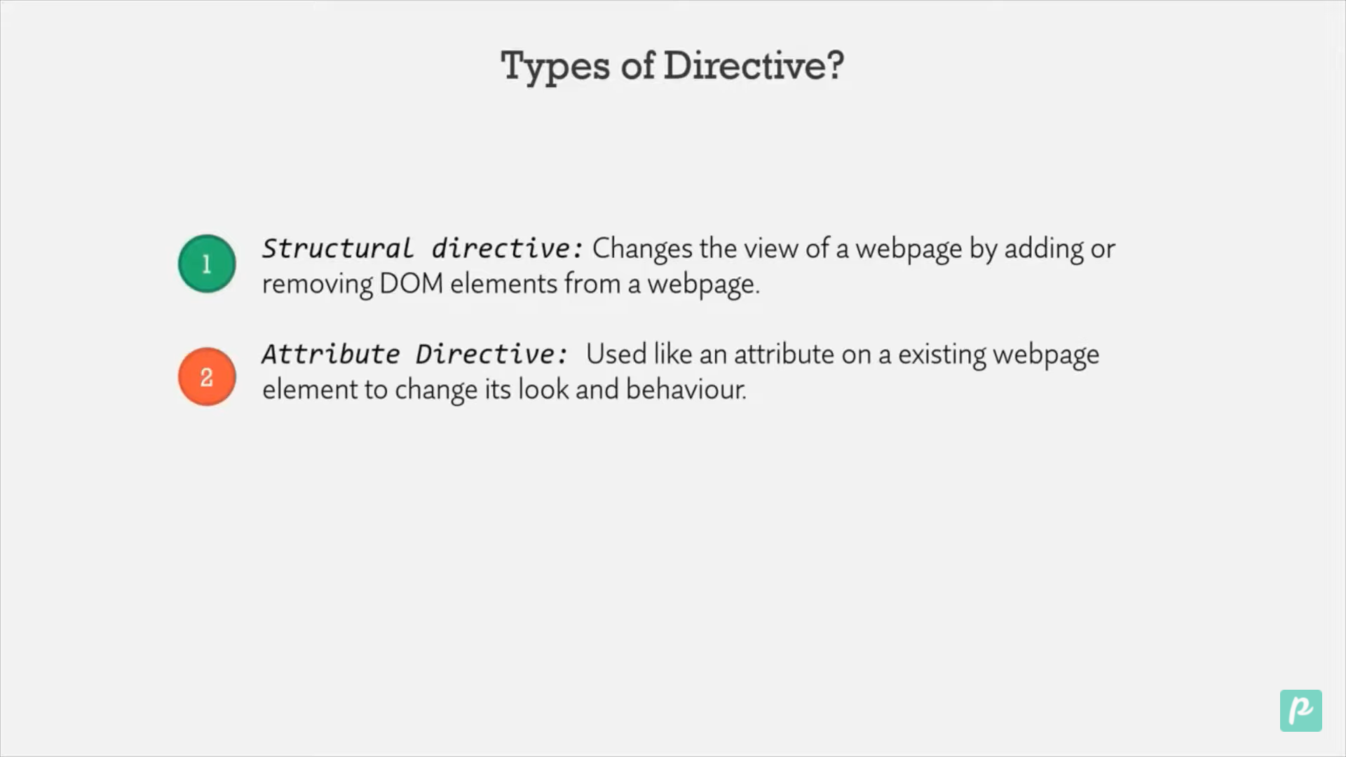



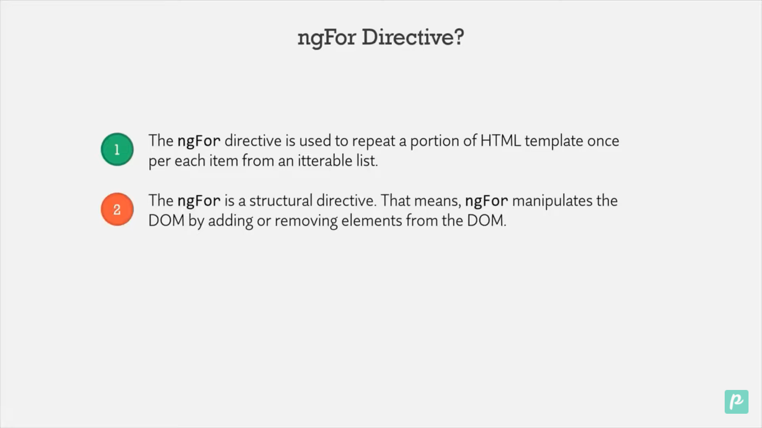

We have to use \* before all the structural directives.

Step1 : we will create one product component to show use of ngFor directives.

Step 2: <div \*ngFor="let item of [1, 4, 8, 9]">

  <p>Number of items is {{ item }}</p>

</div>

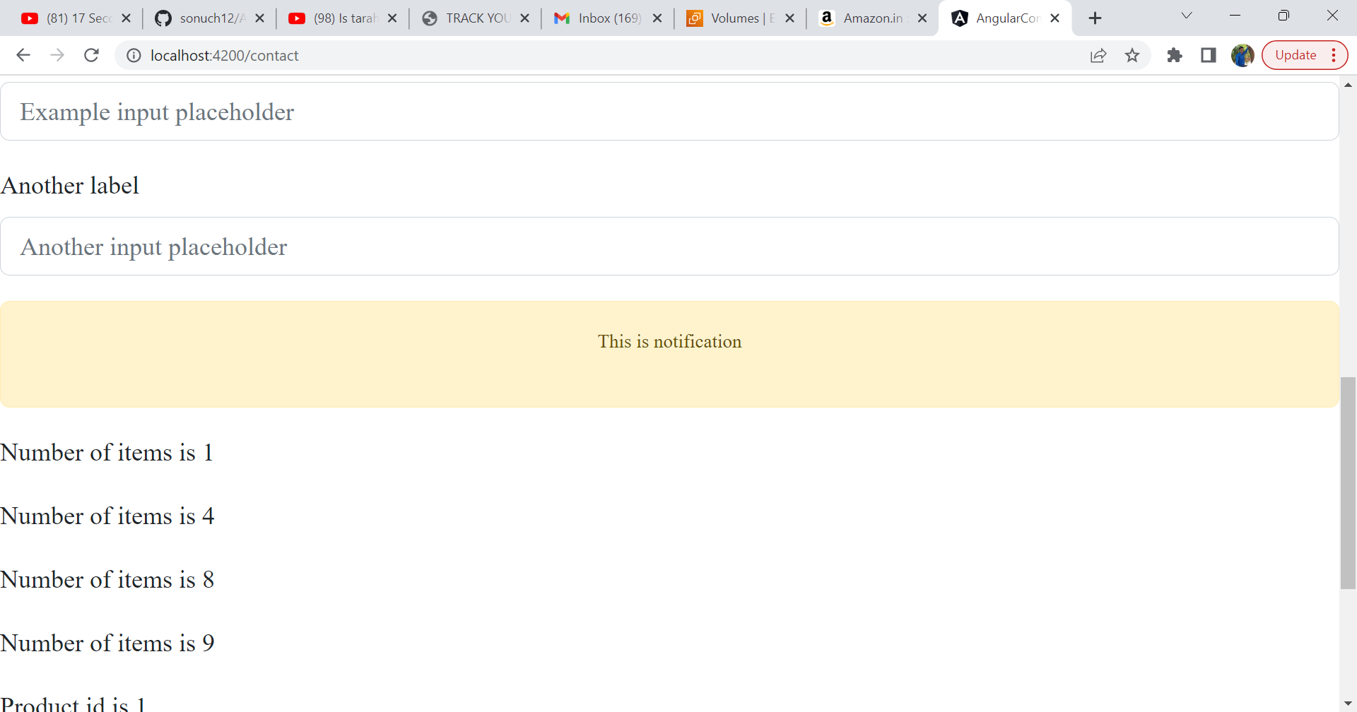

We can create an array in class and call in view template.

export class ProductsComponent {

  pro = [

    { id: 1, name: 'Sam', phNumber: 123456789 },

    { id: 2, name: 'Pam', phNumber: 213456789 },

    { id: 4, name: 'Tam', phNumber: 123456789 },

  ];

And in view template

<div \*ngFor="let p of pro">

  <span>Product id is {{ p.id }}</span>

  <br />

  <span>Product name is {{ p.name }}</span>

  <br />

  <span>Product PhoneNumber is is {{ p.phNumber }}</span>

  <br />

</div>

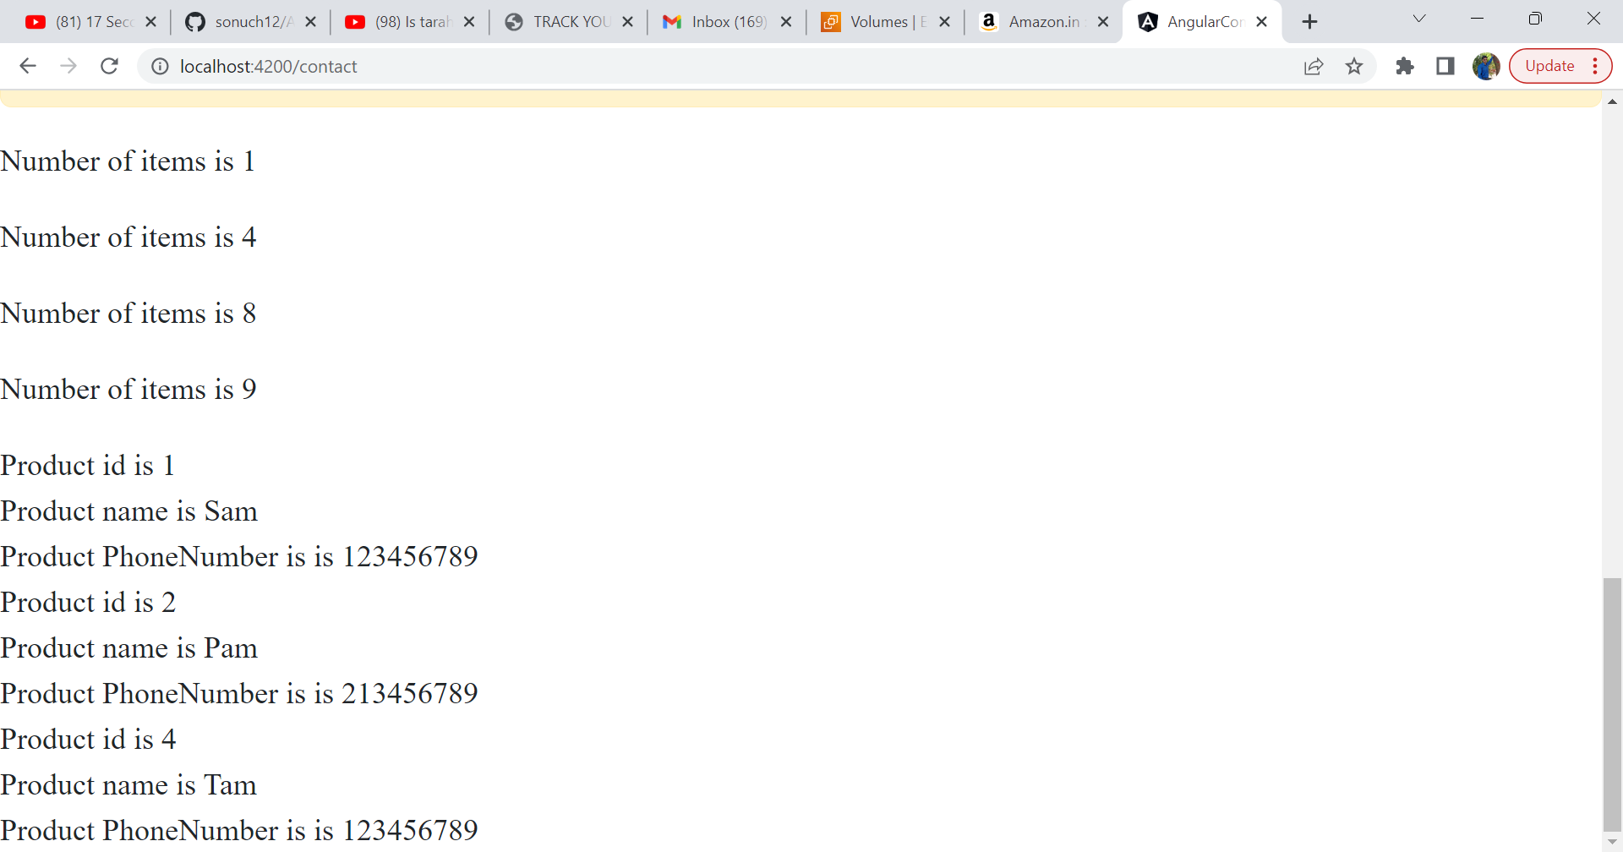

We can use index also<div \*ngFor="let p of pro; let i=index" >

  <p>{{i}}</p>